CSIS 3300-001

Project

Database II

300281074

Jiweon Park

# Introduction

For this project, I have decided to do an Airline Management System. The requirement of this system is building a tool to get all airline information that have airports, flights, passengers and reservations. In addition to just handling airline data, the system needs to keep track of all the data and update or delete it.

# System Analysis

Title: Analysis and Design of an Airline Management System

# Requirements

## Functional requirements

The system will be used for user and airline staff

1. Create, Read, Update and Delete reservations and passengers
2. Get data that a user requests (reservation, flight, airport, passengers)
3. Notification about any updates

## Data Requirements

1. For passenger, keep track of passenger ID, name and age.
2. For Reservation, keep track of passenger ID, Reservation ID, and reservation class. Passenger ID can connect to a passenger.
3. For Airport, keep track of flight number, from and to airport code and flight costs.

## Business Rules and Logic

1. Staff can create a passenger. When it is created, passenger ID will be assigned.
2. A passenger can create a reservation. Each passenger can have multiple reservations.
3. When reservation is created, each reservation will have passenger ID and flight ID so that it can connect to both information.
4. When a request for delete or update is sent, passenger and reservation can be done
5. Client can request report for reservation and passenger if they want to see all the information about them.

# Examples of system input/out

## Examples of system input:

1. A staff adds a new reservation and passenger information
2. Passenger can also create their own passenger
3. A staff requests delete or update for passenger and reservation

## Examples of system output:

1. System create a new passenger and reservation.
2. System keeps track of reservation and passengers
3. System send notification for update and delete
4. System maintains information regarding flight and airport.

# Entity Relation Model

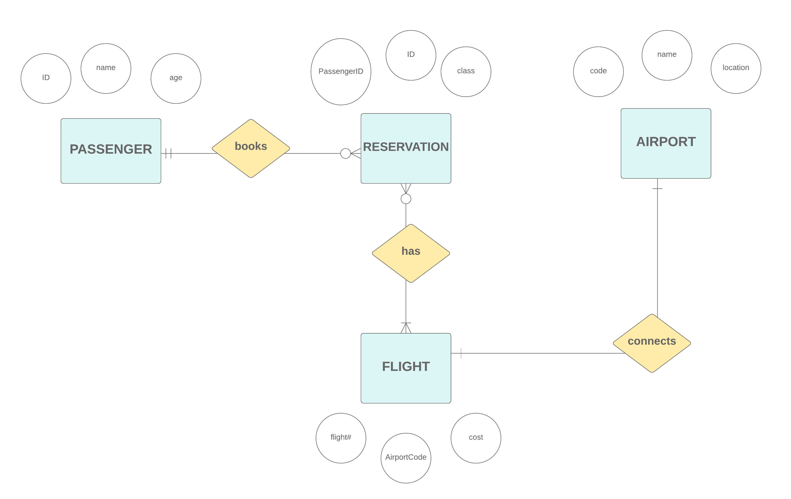

# Data Relational Model

Reservation-Flight entity is created to avoid many to many relationship

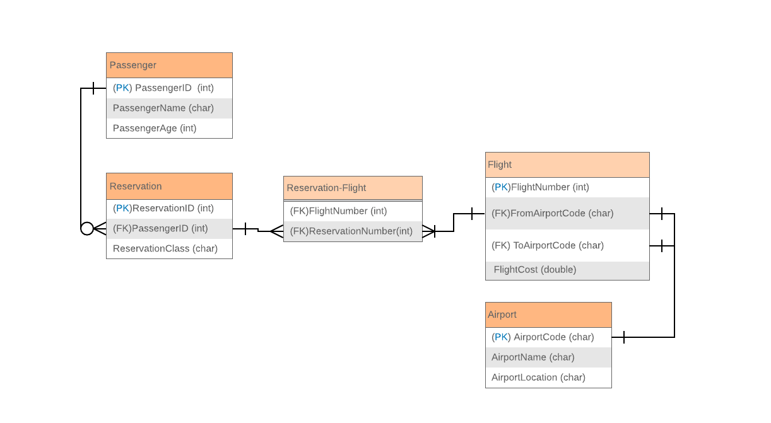

# Role of each group member

This project is done by one team member.

# Gantt Chart

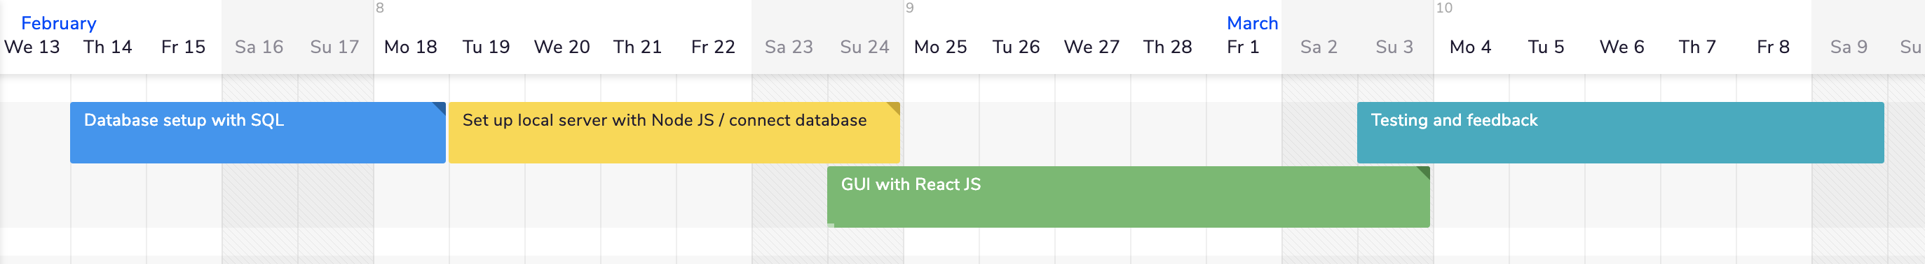

# Functions to implement

1. Create, Read, Update and Delete reservations and passengers
2. Read Flight and Airport information
3. Get data that a user requests (reservation, flight, airport, passengers)
4. Notification about any updates

# Tools

GUI / Front-end: React JS

Local web server: Node JS

Database: SQL